**Unleashing the Power of Product Dynamics in VisCommerce's 3D Room Planner Tool**

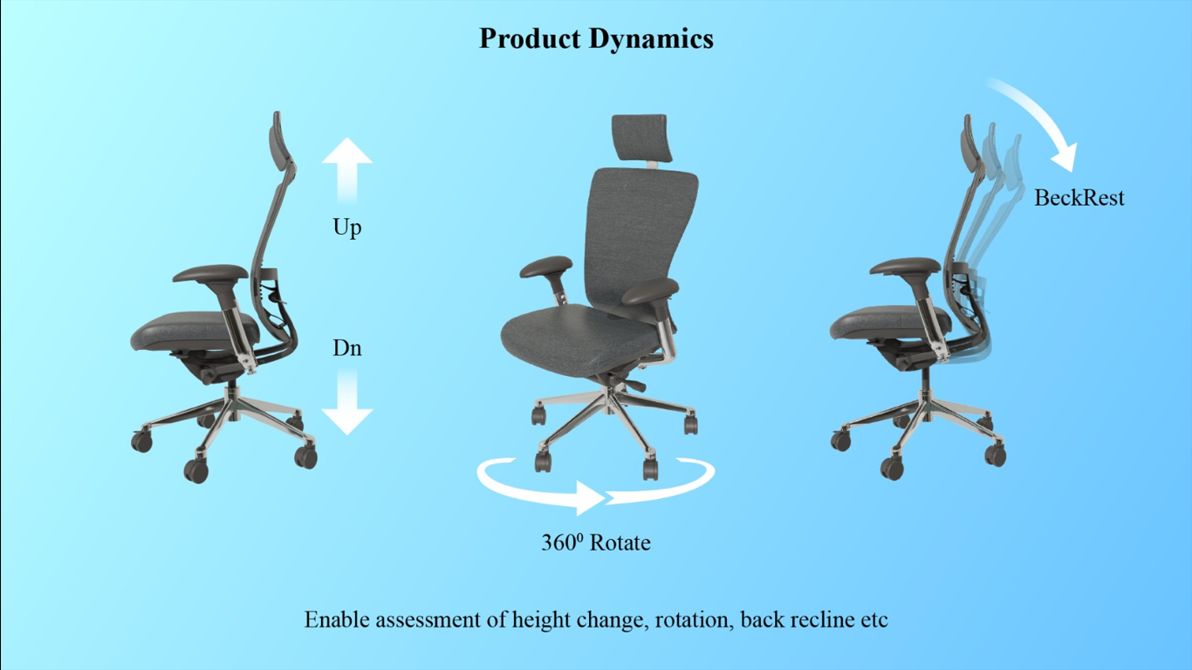

Subject: Unleashing the Power of Product Dynamics in VisCommerce's 3D Room Planner Tool

Dear [Recipient's Name],

I trust this email finds you in good health. I wanted to delve into the remarkable capabilities of VisCommerce's 3D Room Planner Tool, specifically focusing on the dynamic features that enable users to assess crucial product aspects such as height changes, rotation, and back recline. These features are poised to redefine how we engage customers and elevate their shopping experiences.

In today's competitive market, offering a comprehensive and interactive shopping experience is paramount. The dynamic product assessment functionalities within VisCommerce's 3D Room Planner Tool play a pivotal role in achieving this objective.

**Here's how these features can revolutionize the way we present our products:**

* **Height Change Assessment:** Customers often have specific requirements regarding the height of furniture, be it for ergonomic reasons or aesthetic preferences. With the 3D Room Planner Tool, users can dynamically adjust the height of products, instantly visualizing how the changes impact the overall look and feel of the room. This real-time assessment ensures that customers can confidently select items that seamlessly fit their spaces.
* **Rotation Flexibility:** The ability to rotate products within a 3D environment opens up endless possibilities for exploring different angles and perspectives. Whether it's a chair, a table, or any other item, customers can effortlessly rotate and inspect the products from various viewpoints, ensuring they make informed decisions based on a comprehensive understanding of the design.
* **Back Recline Simulation:** For furniture with adjustable backrests, such as sofas and recliners, the 3D Room Planner Tool offers an innovative solution. Users can recline the backrests to visualize the comfort and functionality of these items. This simulation allows customers to gauge the practicality of the products, leading to more confident selections.
* **Enhanced Customization:** The dynamic features of the tool empower customers to tailor products to their preferences. The ability to adjust height, rotation, and back recline ensures that users can explore various configurations, ultimately arriving at choices that align perfectly with their needs and styles.
* **In-Store Experience:** For our brick-and-mortar stores, the 3D Room Planner Tool's dynamic functionalities provide an immersive shopping experience. Customers can interact with products just as they would in a physical store, enabling them to truly engage with the items and assess their features before making a purchase.

I am truly excited about the potential of VisCommerce's 3D Room Planner Tool and the dynamic product assessment capabilities it brings to the table. These features not only streamline the decision-making process for customers but also empower them to make choices that align with their unique preferences and requirements.

Should you be interested in exploring these dynamic functionalities further, I'd be more than happy to arrange a demonstration or discuss how we can seamlessly integrate them into our current offerings.

Thank you for your time, and I look forward to hearing your thoughts.

Best regards,